VRAGEN:
- accuracy
- range
- #repetitions of 0
- smallest nepn number
- largest

UNSIGNED INT subset van N0 (natuurlijke getallen zonder 0)
- BINARY
- BCD

SIGNED INT subset van Z
- SIGN AND MAGNITUDE
- ONE’S COMPLEMENT
- TWO’s COMPLEMENT
- BIASED
- Normal
- IEEE 754 (standard) : floating point exponent

- FIXED-POINT subset Q benadering subset R
- 10 nr 2 => general => IEEE 754 standard
- FLOATING-POINT
- 10 nr 2 => general => IEEE 754 standard

Scientific =
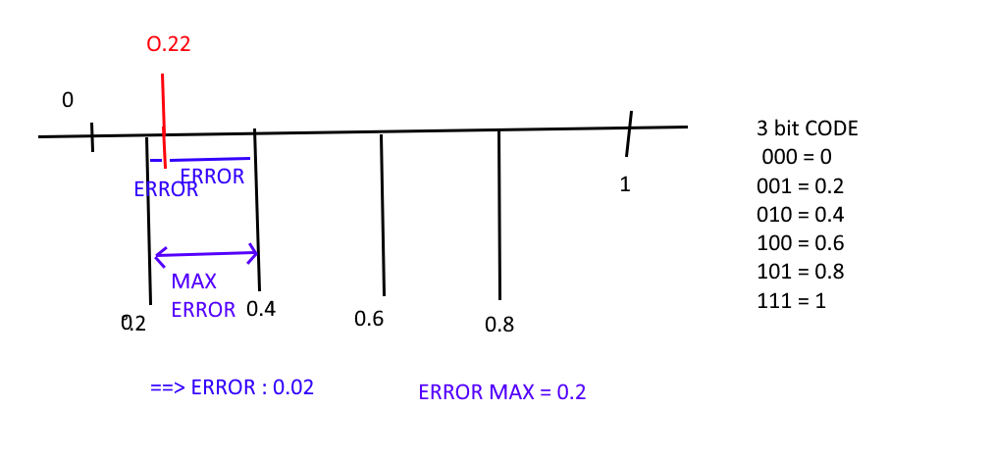
Engineering = , met 10^6 = k en 6 is j

DIA 45 PPT 120
-2 in 8 bits
x = 0000 0010 == 2
!x = 1111 1101 == one's complement
1+ = 1111 1110 == two's complement
FIXED POINT
range = [2⁸⁻¹, ...,-1 ,0 , 1,..., 2⁸⁻¹-1]
MEEST NEGATIEVE : 128/32
0 => 0/32 = 0
dichtste bij het midden 1 => 1/32
alles gedeeld door S en S = 2^{f}
f=5 → S = 2^5 = 32
011.1 1111 = 127/32 ,,, 111.1 1111 = -1/32 ===> optellen 1011.1 1110 (eerste 1 is overflow) = 126
exercise:
#bits = s
S = 2^{f}
[-2^{s-1}, … ,… , … ,2^{s-1}-1]/S
delen door S factor
range = [-2^{s-1}/2^{f}, …, 0 , … ,2^{s-1}-1/2^{f}]
smallest number = 1/2^{f}
equidistance : distance is the same between every number

KLEINE S KLEINE F
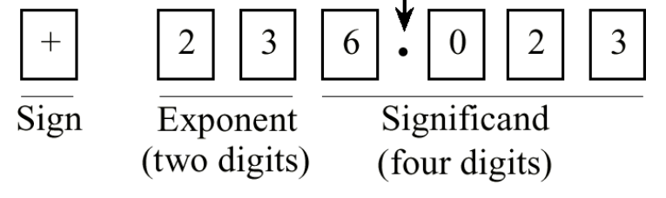

FLOATING POINT
DIA 63
examenvraag:
basis b ==> 8
grootst mogeijk M
kleinst mogelijk m
exponent = 3 bit 2's complement
[-4,0,3]
m M
s = 4 == significant digits

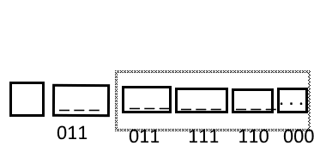

elk vakje = b-1

376₈ = .3 7 6 9 * 8³

GROOTSTE WAARDE VINDEN:
b^{M} * (S/(b-1)(b-1)…) ==> trucje door 1-b^{-s}
==> b^{M}*(1-b^{-s}

range = [-b^{M} * (1-b^{-s}),b^{M} * (1-b^{-s}) ]

